# Harrowing Roads and Epic Hikes

Places mentioned in this post:

Madonna della Corona

Malcesine

Monte Baldo

Riva del Garda

San Lorenzo

Trento

Bolzano

Santa Maddalena

Alleghe

Cinque Torri

(All in Northern Italy)

Within hours of our friends' arrival a couple weeks ago, we hopped in the car early the next morning for a jam-packed and incredible weekend up in the Dolomites. Rich and Andrea had been planning this trip out for months, fine-tuning some details with us along the way. We did not force them to get up and load up into the car that early for a three day journey, ha ha. This

was

the plan all along, and it ended up being pretty amazing!

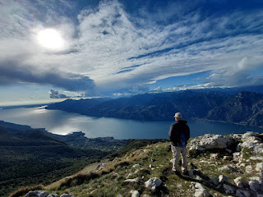

Day One (of 3):

Madonna della Corona, Malcesine, Monte Baldo, Riva del Garda, and San Lorenzo

This was our second time visiting the famous church. It is built into the side of the cliffs below the town of Spiazzi, which is north of Verona. We had such a wonderful experience the first time, and we were so happy to bring our friends here as well. The drive to Spiazzi is about 1 hour, 15 minutes from Vicenza. There is a good parking lot next to the Parc Hotel San Pietro, and the earlier you can park there, the better.

From there, it is maybe a 3 minute walk through town to get to the STEEP paved trail that leads DOWN to the sanctuary of Madonna della Corona. Just remember that what goes down, must later come UP . . . ha ha.

*This is a photo from our first visit 18 months ago in April 2023, where you can see the dynamics of the church and how it nestles into the cliffs.

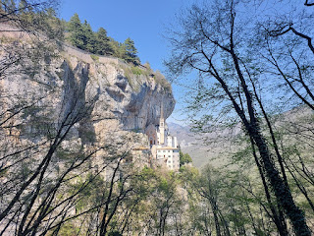

The trail includes several points of interest along the way, called Stations of the Cross. Each station represents part of the story of Jesus Christ, our Savior, leading up to his Crucifixion. Made from bronze, they are all life-sized and quite impressive. The artist was an Italian sculptor named Rinaldo Olivieri, and it took him 10 YEARS to finish this special project. The thing I love most about this part of the trail is that each station helps prepare you spiritually to have a more meaningful experience while in the Sanctuary of Madonna della Corona.

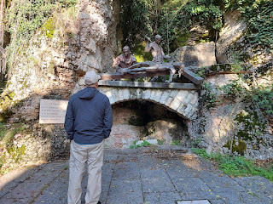

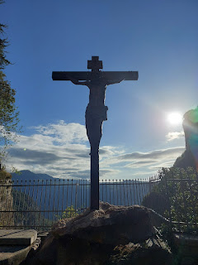

This last sculpture represents Jesus' glorious resurrection, reminding all of us that we, too, can triumph over death, because He did.

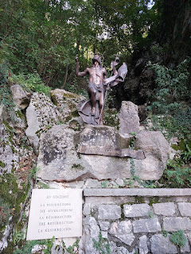

I told Rich and Andrea ahead of time that what impressed me most about this Sanctuary is that EVERYTHING points to Christ. He is in all of the details, big or small. I just really love that so much.

Scott and me on the steps leading up to the Sanctuary . . .

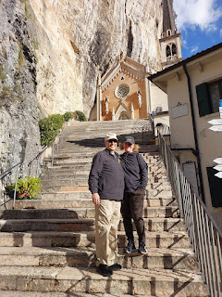

The chapel, as it stands today, was built in 1530. It fits into the cliffside of Monte Baldo, high above the Adige River Valley. It has received numerous expansions and renovations over the centuries, including a large expansion in the 17th century to accommodate the growing number of pilgrims.

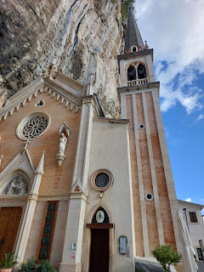

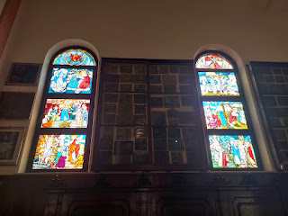

Just inside the doors of the Sanctuary, there are 167 tablets called "ex-votos" on display. They are various representations of a special experience that has taken place, and the offerings are made by pilgrims to show their gratitude and reverence for an answered prayer or a miracle in their life. They are expressions of devotion and even a testimony of their personal faith, acknowledging a heavenly intervention in their life. The oldest ex-voto dates back to 1547.

(Click photos to enlarge) I'm sorry about the angle of the photos, but they were high above my short little stature and without a 12 foot ladder, I did the best that I could.

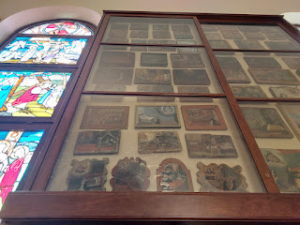

Many of the depictions seem to be of someone in the act of praying near their bed for a loved one, or in behalf of someone who is sick or dying. There is even a dramatic painting of someone clearly falling down the stairs, but who must have ended up okay, and their artwork shows how they were protected in some miraculous way.

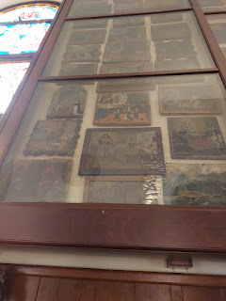

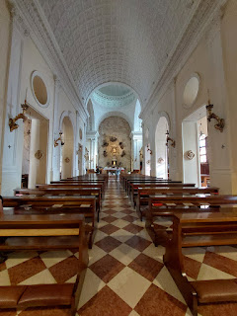

In a side chapel, there are several small confessional booths of varying language capabilities and several benches to sit on while you wait. On the left is a foyer where you can further cleanse yourself with holy water (if you are a practicing Catholic) after your humble confession. This is all in preparation to ascend the Holy Steps. (click photo below to read more of the specifics)

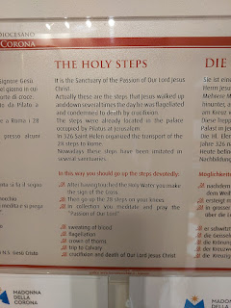

I couldn't help but compare some of the specific instructions on how to reverently prepare yourself to ascend these steps with some of the practices we keep in the Church of Jesus Christ of Latter-day Saints as part of our preparation to attend the Temple. We try to keep God's commandments as best as we can; we repent often (through personal prayers and even visits with our Bishop if needed); we meet with a member of our clergy every two years to receive a temple recommend - which is essentially US recommending OURSELVES to the Lord and declaring ourselves worthy to go inside the House of the Lord (the temple); we prepare our hearts often to receive reverent and personal instruction (through prayer, scripture study, meditation, etc); and all that we strive to do should ultimately point to Christ Himself.

Even in the Temple, the Holy House of God, there are MANY symbolic things that we see and do. One is that through a series of instruction rooms, we ASCEND to the highest room by the end of the endowment session, a room that is symbolic of the Celestial Kingdom, or the place where God and His Son, Jesus Christ, reside. There has already been much preparation in advance before we ever step foot into this beautiful and sacred place.

Similarly, those who wish to ascend these Holy Steps in the Sanctuary of Madonna della Corona are asked to purify themselves and make sure they are fully ready and prepared to "go up" to a higher place, with Jesus Christ at the center of everything they do.

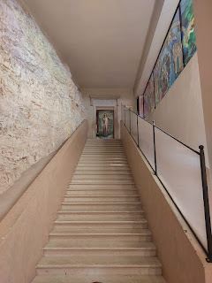

I didn't know this until now, but a man who was seated nearby (a member of their clergy), indicated to us that we could go up the steps on the SIDE - to the right of the Holy Steps. Wow, what an honor! As we reached the top, I was struck by the beautiful painting of Jesus as the "greeter". We all hope and strive to be a good person, but ultimately, we want to be like HIM. He is the reason for all that we do, live for, and strive for.

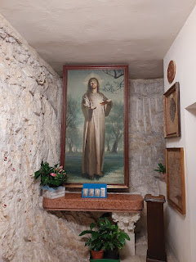

To the right is a small hallway, along with this tender scene of Mary holding her son, the Savior of the World.

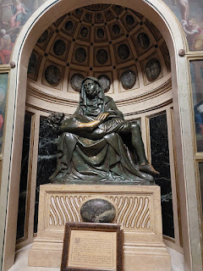

I immediately got emotional as I noticed a spot where the brass sculpture was a little worn . . . where people had reached out to touch the arm of the Savior - for comfort, for peace, for hope, for a reminder of why we go through all the things that we go through in this life. If He, the most perfect and holy Man to ever walk this earth could suffer ALL things (loneliness, illness, pain, exposure to deep and dark sins, addictions, loss, lack of confidence, etc.), and then miraculously rise above all of these things to suffer no more,

this gives US hope

. We, too, can rise above all of the struggles that we have in this life, and we can lean on Him - because He knows what we're going through. He has suffered through the exact things that we now face! Why? So that He can know how to help us through that stress, that strain, that difficulty, that pain, and that loss. He knows how we feel because He has felt it, too.

Video of a lady playing some sort of stringed instrument in the adjacent room, adding to the peaceful spirit of the place where we stood: (37 seconds) *Note - the music is very quiet and faint.

https://photos.app.goo.gl/t5V43wZHVbf1xafd7

I really felt the spirit of God as I stood there at the top of the stairs, in that little alcove, in front of that statue. I felt a sense of belonging and inclusion, reminding me that all people, throughout the centuries of time, have yearned for this same sense of peace and contentment. There are many religions in the world, and even more churches. But we are One Family as far as God is concerned. And if we strive in the best ways that we can to follow His commandments, to become more like our Savior, even if we differ somewhat in the execution of this plan, He is mindful of our efforts. He is merciful with whatever we may lack. We do need to listen to the Holy Ghost in discerning what is truth and what is maybe just a nice effort. Our Father in Heaven does have expectations of us, and it's up to us to determine how committed we are to Him and to His Son.

But He does reward effort. And I felt in that moment, that He was appreciative and full of love for each person who has come to the bottom of those Holy Steps and who wanted to become something more than they currently were.

So many pilgrims have come to the Sanctuary, either with hope for a miracle, or to give thanks for one that has already taken place. They often bring a photo, a drawing, or something carefully crafted (like a cross-stitch) to express their thanks.

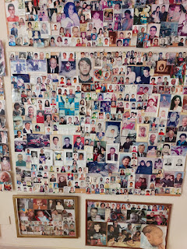

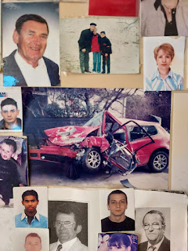

I love the tenderness that Mary is expressing to her precious Child in this painting . . .

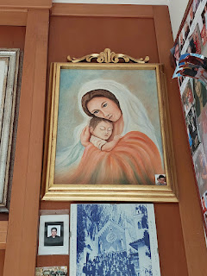

Careful efforts were also taken in the creation of these clay sculptures, too, each one demonstrating a love for Jesus Christ . . .

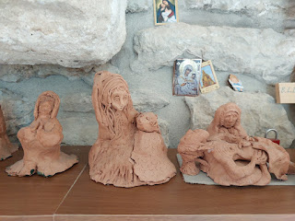

The Garners really enjoyed their visit to Madonna della Corona. I was grateful that Scott and I could go a second time. I feel like it really solidified my reverence and love for Jesus Christ.

We hiked back up to the little town of Spiazzi above, and began driving to our next location: Malcesine.

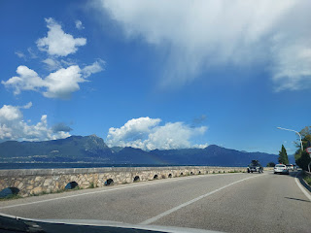

Because it was a beautiful, sunny Saturday heading into the fall season, I think everyone wanted to be at Lake Garda that day. We were bogged up in traffic for a while before we could even enter Malcesine (pronounced - "Mal-cheh-SEEN-ay"), and where we had chosen to navigate to for parking was simply out of the question. Everything was packed beyond packed. We drove quite a bit further out than we had set on our GPS, looking for ANYWHERE to park, and finally found a place near a very cute restaurant. Happy Day!!

I ordered a grilled chicken with an assortment of grilled fruits and vegetables - something I had never considered before. The grilled fruit was so fun with the chicken! They served up grilled figs, peaches, and plums, plus some grilled red onion, broccoli, and fresh herbs.

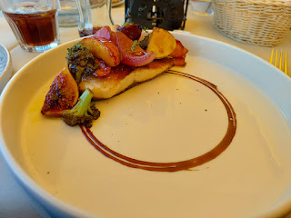

Video of the nicest bathroom I've ever had the privilege of using in Italy: (10 seconds) This was the restaurant bathroom, and because the owners have a little girl (they all live upstairs), they literally thought of everything!

https://photos.app.goo.gl/mxvUAce39xfWFv2N7

Kumquats are coming into season again . . . Scott's favorite fruit! This little tree was in front of the restaurant where we had lunch.

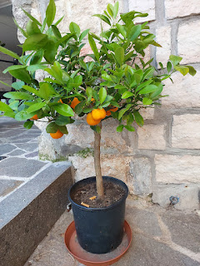

A few other pretty flowers and berries that we saw on our walk down into Malcesine . . .

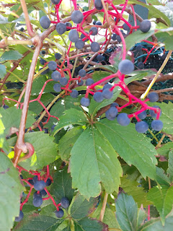

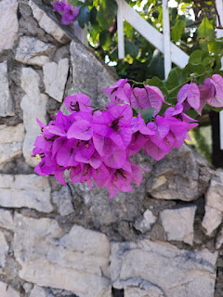

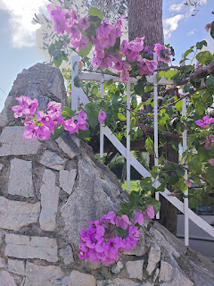

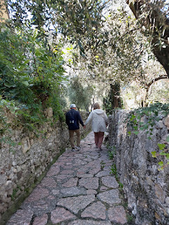

We found a shortcut down to the lake (on accident), and it was such a beautiful sight to see the colors of the water against the bright blue skies.

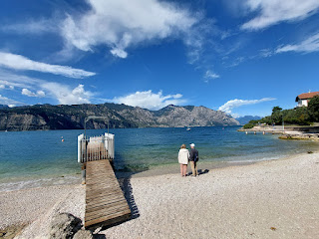

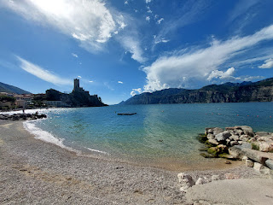

We made our way over to the Castello Scaligero di Malcesine . . . built a very long time ago . . . (more on that in a minute)

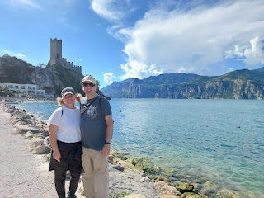

But first, Scott found a good spot to send the drone up, right at the base of the castle and next to the lake! He hasn't had time to edit the footage from the past couple of weeks yet, but I'll share a link when everything is ready.

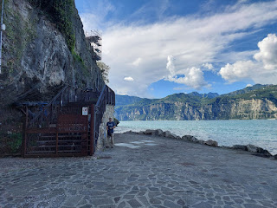

I always love to take a picture of the drone before it takes off . . . :)

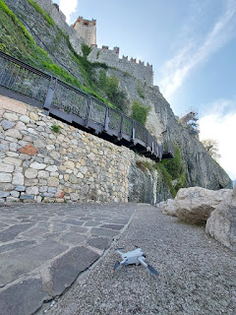

From where we stood, you can just make out the cable car that goes up to Monte Baldo - there's a secondary station halfway up the mountain, and there you can see more clearly the path that transports passengers up to the very tippy top. (We'll be going up there shortly . . .)

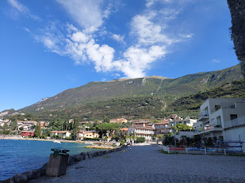

Another cute and random free library of books - take one, leave one.

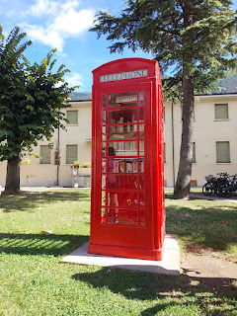

After winding our way through the historic area surrounding the castle, we finally got our tickets and entered the huge fortress . . .

Rich and Scott were often out in front of Andrea and me. Sometimes they would be so deep in their discussion of sports or whatever topic it was, that they may have even forgotten about us, LOL.

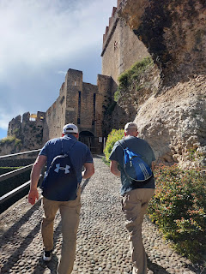

Andrea asked Rich to take some pictures of "the ladies" just walking and talking, so we decided to ham it up a bit. I tried REALLY hard to get the second photo of us inserted, but it refused to go into the right spot, I'm so sorry. You'll have to see it waaaaaay down below instead . . .

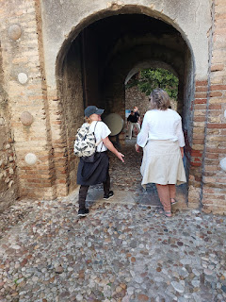

We learned a lot about the history of Lake Garda in the Castle's museum. There was a lot of fighting going on throughout the centuries here, everyone wanting to be in control of the lake and the ports and the shipping of goods. This next photo describes some of the items that were recovered from the Lake and what they were used for. (click photo to enlarge)

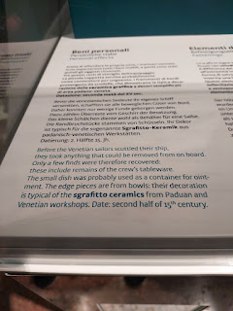

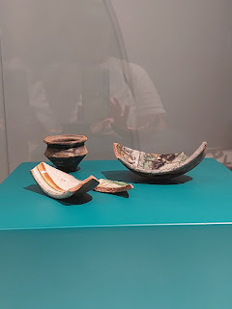

Sometimes Scott's brain gets tired of too much information coming in, especially if it's in the form of a museum. His two least favorite things in the world are crowds of people and being part of a tour group. While we weren't exactly in a tour group, we were still sort of on a "tour" of discovery as we made our way through the museum portion of the castle. Often, he will go way out ahead, skipping the things that don't interest him much, and I sometimes lose track of where he is. This time, I found him outside sitting on a bench. When I asked him what he was up to, he replied, "Just checking on our mutual funds." What a character. XOXO That was his way of saying, "I don't really care about this stuff very much. Just get me to the cool stuff!"

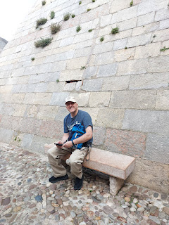

Rich and Andrea were soaking it all in, though. Rich likes to wonder as he wanders, and he asks lots of questions. He really likes to connect to everything he's seeing. They were in no hurry, which is kind of a nice thing.

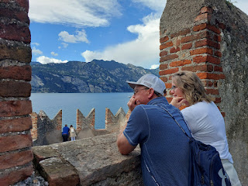

The views were pretty amazing . . .

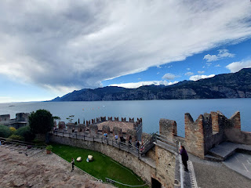

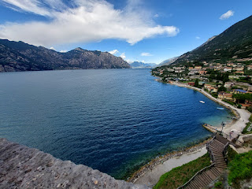

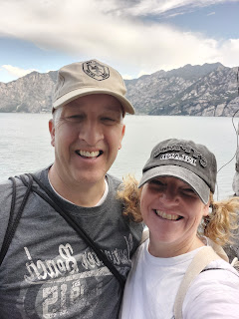

Here's the information about the history of the Castle. I'll type it up for you below the photo.

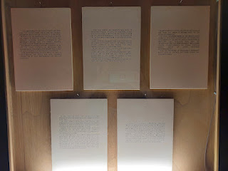

It is impossible to say when and who built the Castle, since there are no official documents which report the date of foundation. Nevertheless, we know that the rock on which the castle is situated, thanks to its high and isolated position, always represented an important refuge and the surest military bulwark for the inhabitants of Malcesine.

According to reliable historic sources, in 590 AD the local fortress in Malcesine was destroyed by the Francs: this means that a part of the castle already existed before that period. Then, when Malcesine passed under the rule of Charlemagne, the castle was very probably rebuilt or at least rearranged for military purposes.

Also, the tower (or Mastio) was built in different periods. At the very beginning, it was not higher than 15 meters, which results from the different workmanship of the cut stones on the outside walls and from other architectural elements. Some scholars maintain that this first part of the tower could date back to the Roman period. Others, however, do not believe this, since Romans never used a pentagonal base.

In the second period, i.e. 1131, the tower was raised further to the fourth floor. Some time later, the observatory was built, with the six arched windows with their lowered centre and a flat frame of bricks, typical characteristics of the Romanic style.

At present, the tower is 70 meters high on the lake level and 31 meters high on its base.

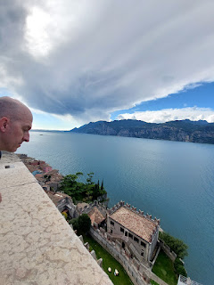

Continuing:

An important date in the history of the castle is the year 1277 when it became part of the Scaliger dominions. Also the restoring of Malcesine's boundary walls, used as defense, was done during the Scaliger period.

In June 1387, the Castle was occupied by the troops of Galeazzo Visconti, that remained there until 1403. In 1405, Venice took over the castle. The dominion of the "Serenissima Venetian Republic" brought a long period of political stability and peace in the area (from 1405 to 1798).

During this period, Venetians introduced new elements of defense within the original structure of the castle in order to conform to the modern fire-arms.

It is certain that the lower palace (present Museum of Natural History) was modified in the first part of the 17th century. Then, when the seat of the lake captaincy was moved from here to "Palazzo Dei Capitani", in the center of Malcesine in 1618, some rooms were used for mainly military purposes from which the name "Casermetta" (Little Barracks) is still used for one of the buildings in the castle.

During the Austrian domination (1805-1868), important works were done: a new room used as a "powder warehouse" ("Sala Goethe"), was completely built and an official survey of the castle was carried out for the first time.

Consequently, maps of the entire building were printed, which had fundamental importance and understanding of historic and architectural events in the castle.

In 1902, the Ministry of Education declared the Castle of Malcesine as a "National Monument."

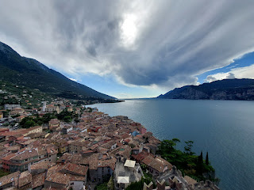

As I looked over one of the upper balconies and stood there for a while, I noticed a bride and groom having a photo shoot on a balcony down below in the town.

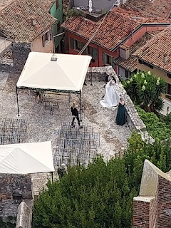

To give it some perspective, I'll zoom out a bit . . .

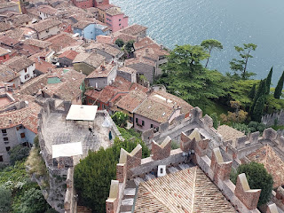

Now a little bit more . . .

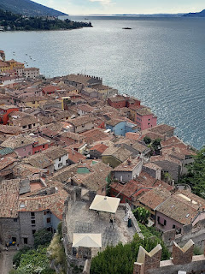

Even though there are a lot of houses in Malcesine, plus a lot of tourists and visitors, this perspective says a lot. Even with a lot of stuff going on in the world, what each person is doing matters a great deal. This was just one event going on that day, among thousands. But how special that I could catch a small glimpse of their special day.

A short time later, they came over to the castle for a few more photos, close to where I was standing.

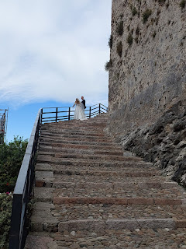

While we were up on top of the tower, all of a sudden the bell started clanging and made several of us jump, ha ha. It was on some sort of automatic timer, I think.

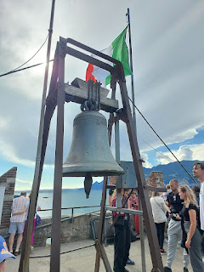

This map shows where we went next: up the cable car to the top of Monte Baldo.

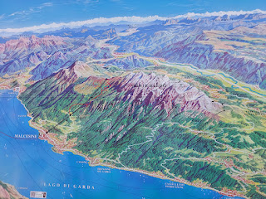

Scott and I came up here two years ago, but via a different route. The cable car was closed that day for scheduled maintenance, so we decided to drive up the back side. It was a twisy, curvy road that got pretty exciting at times before we had to park and hike the rest of the way up (about 2 miles). But man, what a view!! We knew it would be fun to take the Garners up there, but this time we would use a much easier route.

A group of alpacas live at the top . . . and what a fabulous life they get to have!!

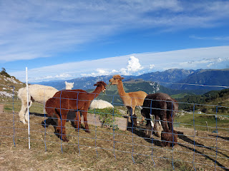

Video of a lady giving them some fresh greens to munch on: (13 seconds)

https://photos.app.goo.gl/YckfqWD6zTNXFD7R9

While the guys forged ahead, Andrea and I decided to investigate a little boutique on top of the mountain with dozens of products made from the alpaca wool. I ended up getting these darling and super-soft booties for Maisie, while Andrea was oh-so-happy with a very colorful alpaca-shaped keychain.

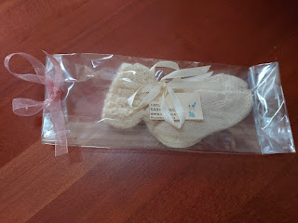

As is the custom in Italy, when you make a purchase, they wrap it all up with love and make it look oh-so-special. I took a picture of the girl as she selected some ribbon, fashioned it into a little bow, and then stapled it onto the bag.

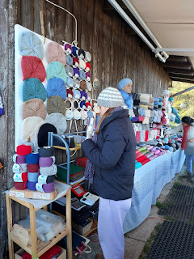

We loved seeing those cute little alpacas at 1760 meters (5774 feet). And how nice that their silky soft and very warm wool can be used in the chilly seasons wherever you are in the world, whether it's Northern Italy or Minneapolis, Minnesota. :)

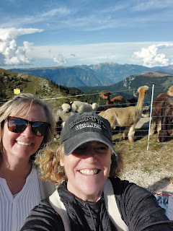

Andrea and Rich, walking on top of the world . . .

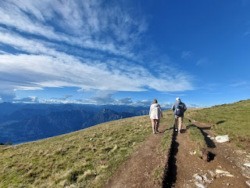

Scott, Andrea, Rich, and Me . . .

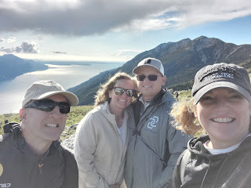

Scott tried to convince this cow to come over and eat some grass out of his hand, but she paid him no mind . . .

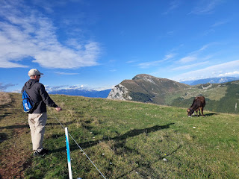

Video #1 as we approached the cows: (23 seconds)

https://photos.app.goo.gl/3YvbsPpytqWLeq2a6

Video #2 of the cows with the clangy bells around their necks: (11 seconds)

https://photos.app.goo.gl/nC3bM4EgjnutoEFU7

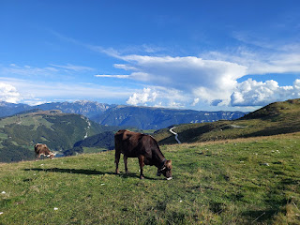

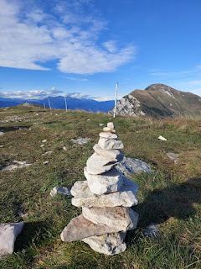

Looking toward the northern end of Lake Garda, where our next stop would be in Riva del Garda . . .

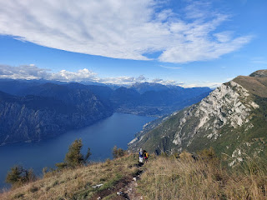

A group of German paragliders were setting up next to the cows. They hopped right over the fence and began prepping to launch off the side of the mountain, as if they'd done this a dozen times already. The wind was pretty strong that afternoon, so strong in fact, that Scott didn't feel safe launching his drone up there. But that didn't deter these guys one little bit . . .

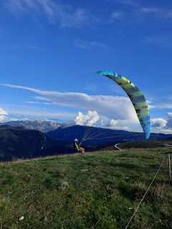

This guy struggled for the longest time. Every time he'd get his chute up, the wind would send a hefty gust that caused it to get all tangled up again. But he never gave up. Even the cow, munching on that sweet alpine grass next to him, watched patiently to see how it would all play out.

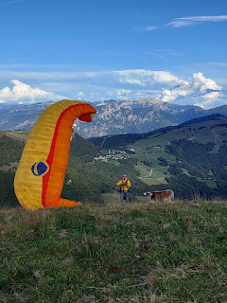

Eventually, one by one, they took off, soaring back and forth, using the wind to their advantage as they worked their way down to wherever the landing spot was below. While I was busy videoing, which took a while in between each person getting ready for take-off, Scott, Rich and Andrea were busy watching from the other side of the mountain - overlooking the lake. One of the earlier paragliders had made his way around to the lake and was floating all the way across, seemingly just barely above the water. They marveled (and stressed) over whether he would make it across or not. They thought for sure he would end up in the water, but somehow he miraculously made it all the way safely to the landing zone. They reminisced about that guy for the next several days!!

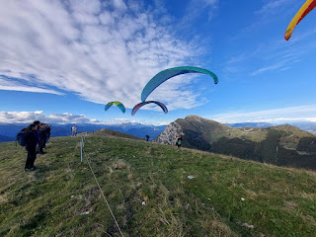

A series of videos that I'm gonna make into a reel for Instagram and Facebook:

When life doesn't seem to offer any wind that could help you: (7 seconds)

https://photos.app.goo.gl/e1BkaU2d71G2ydck6

Or you're just "bobbing along" and nothing makes a whole lot of sense: (6 seconds)

https://photos.app.goo.gl/NYSKVxQF4XZe32pr8

Or when life throws in some twists and turns that cause you to fall flat: (18 seconds)

https://photos.app.goo.gl/1MwLMp7YE5gd8gwT8

Or when it's a serious struggle to keep your feet firmly planted on solid ground: (20 seconds)

https://photos.app.goo.gl/kEjb7BZPhT12XZreA

Or when you've crashed too many times to count: (4 seconds)

https://photos.app.goo.gl/dJWxeAgT3oSjkVy79

Or when it seems like you're the only one struggling and others seem to gracefully glide along: (34 seconds)

https://photos.app.goo.gl/4ueWCYtLUPEjeeau9

Never, ever give up! Keep those feet firmly planted on solid ground. Untangle yourself, and point yourself in the right direction. Keep trying. And eventually, you'll get there! (1 minute, 3 seconds)

https://photos.app.goo.gl/kZ6z6VpciTW7ZLFY8

And if you can, have a little fun along the way: (20 seconds)

https://photos.app.goo.gl/KzQDF5o3RxaPn4vG8

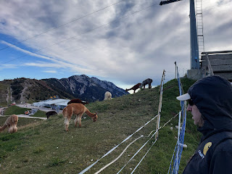

The wind was brisk and the temperatures were getting colder as we made our way back to the cable car station to head down the mountain. My hands had almost turned into popsicles as I stood there videoing all those paragliders for so long!

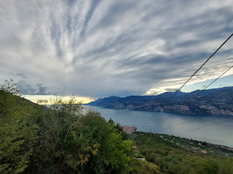

Video of the last stretch of the descent into Malcesine: (16 seconds)

https://photos.app.goo.gl/5MuhyHT4Hw52d2iBA

Little whispers of pink cotton candy were starting to crop up in the sky as we pulled into Riva del Garda.

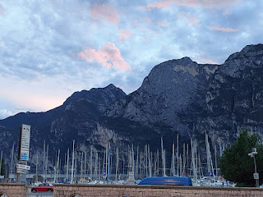

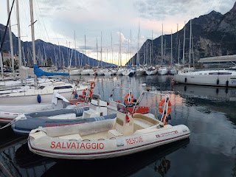

What a cute town! Scott and I had never come this far north along Lake Garda before, but wow, it had a lot of offerings: a scenic harbor, a nice beach, walking paths, duckies, live music, restaurants, a campground nearby, etc.

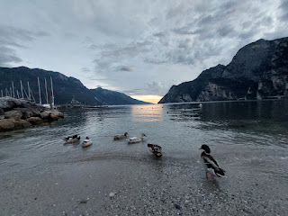

Video of the ducks, the lake, and the sunset: (11 seconds)

https://photos.app.goo.gl/i3KdBCjonPQkPN3g9

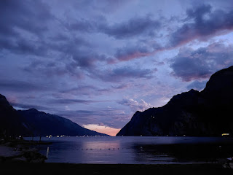

We didn't really have any agenda in Riva del Garda, only that Rich wanted to stop here, so we did. Scott and I sat on a bench for a little while, watching the sun go down, and then we slowly wandered along the walking path for a bit before turning back around. We grabbed some kebabs and burgers to take to our hotel, and then we made our way up into the mountains north of Lake Garda on another exciting curvy road. Rich slept through it all, ha ha.

Our hotel was located in San Lorenzo, high above Trento, in a very tiny town (population roughly 1,600). Our building was slightly down the street from the main hotel and the check-in desk, but it definitely had that WOW factor!!

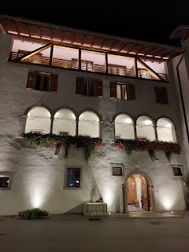

The Hotel San Lorenzo acquired this additional building in 2020 and renovated it to provide a few more rooms. It was originally built in the 1400s, but I couldn't find anything more specific about it. The outside looks like it may have been a barn at some point . . . It was our favorite hotel out of the several that we've stayed in over the past year or so.

Our room even had space for all of our grandchildren upstairs in the loft, ha ha. I just wish they could have been there with us. While we only needed the one bed down below, Scott discovered 3 more beds upstairs!

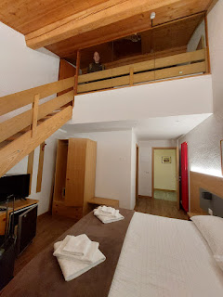

We had a balcony, too, so we sat outside to eat our almost-cold dinner before going to bed. :)

So, um, here's the photo that wouldn't go into the right spot up above . . . LOL

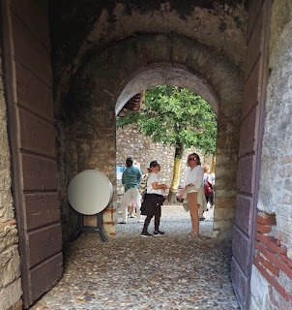

Day Two (of 3):

Trento, Santa Maddalena, and Alleghe

After a great night of sleep in that cold mountain air of San Lorenzo, and after a delicious breakfast in the main hotel down the street, we got packed up and ready to drive down the mountain into Trento for church.

The morning view from our balcony . . .

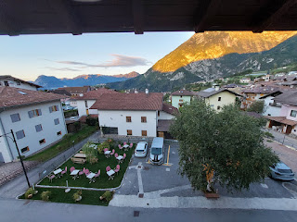

Some wild hollyhocks were growing next to the old barn, and they reminded me of the time that Charmaine (my sister) very sneakily brushed some hollyhock seeds from a live plant in Claude Monet's garden (in Giverny, France) back in 2018. The plant was about to go dormant for the winter, so she didn't see any harm in taking a few seeds. All in one motion, she pulled out a tissue from her pocket, deposited the seeds into the center of it, wrapped them up carefully, and then shoved the precious packet down into her pants pocket and kept on walking. LOL

I remember my mouth being as gaped open as it could get, panicking that we would be spotted, subsequently arrested, thrown into a French jail where no one spoke English, and that we would never be heard from again . . .

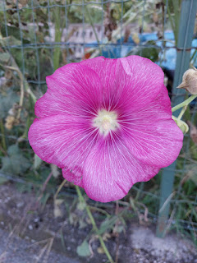

All turned out well, though, thank goodness. No one even noticed. She got the seeds through customs when we landed back in the U.S., and within a short time she planted them at our old Snider family home on Sanford Ranch Road in Ukiah, CA - where she was living at the time. They are still flourishing and blooming each year! Hollyhocks from Claude Monet's GARDEN are alive and well in Ukiah, California!! But SHHHH, don't tell anyone about this . . .

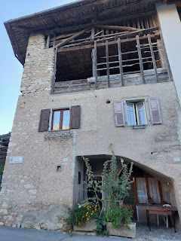

This shows the portion of what I think might have been an old barn - it's also attached to the hotel extension where we stayed.

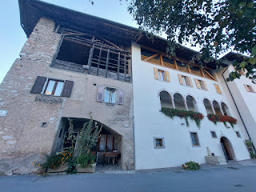

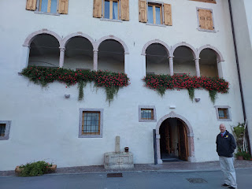

A gorgeous painting hanging in the hotel corridor, showing women from yester-year doing their wash in the public water source out on the street in front of the hotel . . .

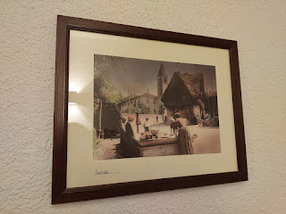

Short video as seen from our balcony: (10 seconds)

https://photos.app.goo.gl/pgUEtV1sJufVXK7BA

We drove down the curvy mountain road into Trento to attend church there. It's always so interesting to me to see what kind of places are being used as a church building outside of the U.S. This was an older commercial building tucked behind a few other shops on the main street, with the tiniest parking lot ever. We got there early enough to grab one of the 4 parking spots. Otherwise, we would have been cruising up and down and all around trying to find an available opening.

This particular congregation was so tiny, that they are organized into a "Branch" instead of a "Ward". A branch can be as small as a handful of members, while a ward can be up into the 100's of members. I think the biggest ward we've ever been a part of (in the U.S.) had roughly 700 members at one time, shortly before they split it into 2 wards, which helps it to be more manageable.

This branch, if I could venture a guess, had maybe 25-30 people in all. And guess how many primary children? TWO. Both were sisters and were from somewhere in Africa. They were super cute. This is their tiny little primary room . . .

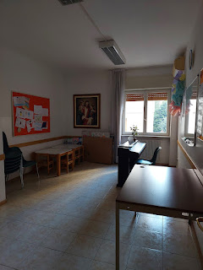

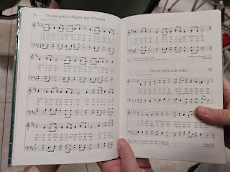

Video of us attempting to sing the opening song in Italian (sorry for the wobbly start of the video as I tried to get my phone & the book situated): (46 seconds) "We Thank Thee, Oh God, For a Prophet"

https://photos.app.goo.gl/y2Xk6uGKL8PJE6EY9

The Sacrament Hymn - "We'll Sing All Hail"

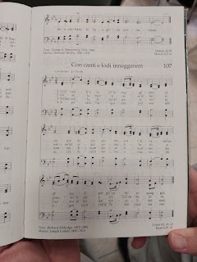

The closing hymn was "Love One Another" . . .

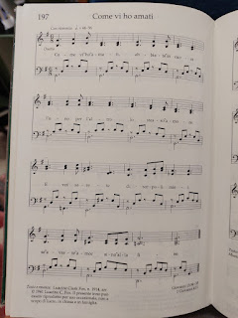

Video of us singing the closing hymn: (1 min, 2 seconds)

https://photos.app.goo.gl/dDfsEX2vpcH33Gn59

*Note: I tried to sing the alto part a little further down, but I got lost in trying to read the foreign words

and

keep a decent tune!! LOL It's a good thing Scott always drowns me out, anyway . . . :)

After church, we drove to a nearby spot that Rich had found online. We were excited to see a waterfall just 10 minutes from the church building, but when we got there we learned that you can only participate by joining a tour group, and it would be about 45 minutes to one hour in total. As soon as they said guided tour, Scott was like, "I'm out." ha ha

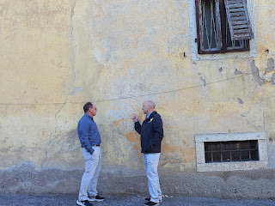

So, after regrouping, we decided to continue on by heading to Bolzano next. Bolzano has an amazing Christmas Market in December, and I was supposed to go with the "Wednesdays in Italy Group" last year, but I was too sick to join them. I was excited to see Bolzano this time with our friends, because I had heard that the river was especially beautiful and that the town was very cute.

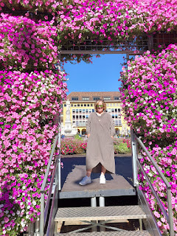

However, we were under-impressed with Bolzano. We visited the Duomo in the historic downtown area, and we walked around a bit, but other than the cute photo spot with the pink flowers (above), we just didn't like it. The streets were dirty, there were a lot of homeless people, there was a ton of construction going on everywhere, and we weren't feeling enamored. So we left.

We drove to Santa Maddalena - a truly charming village approximately one hour to the northeast of Bolzano. Scott and I stayed here last September when he hiked in the Dolomites over Labor Day weekend and we have very fond memories of this darling little town.

First, we stopped to eat lunch at a place where Scott and I had eaten last fall: it's called Hotel & Restaurant Fines. I ordered this platter that looked too pretty to eat!!

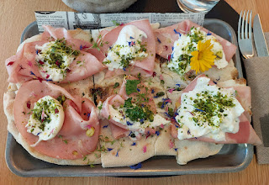

It consisted of flatbread, thinly sliced ham, goat cheese and burrata cheese, herbs, chopped pistachios, and edible flowers!! Wowzers. It was delicious. :)

After our tummies were happy and our bladders were emptied (it's always a good idea to use the toilet inside the restaurant so you don't have to pay 1.50 somewhere else), we started off on the short hike up to the Santa Maddalena Church. This 15 minute walk has some spectacular views of the Odle Mountain range (part of the Dolomites).

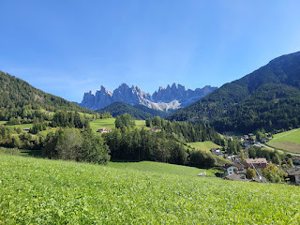

Below: You can see the church on the left, and the Odle Mountains on the right . . .

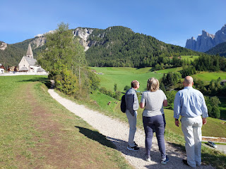

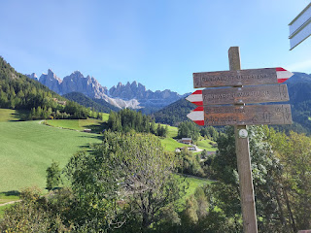

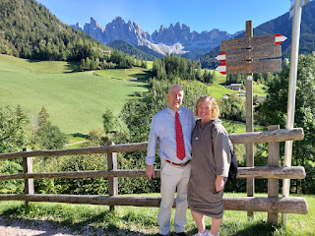

Scott, Me, Andrea, and Rich . . .

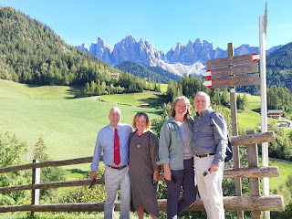

On our way back down to the car, I saw this adorable little fluffy dog, and I asked his owners if I could take a picture of him. They happily obliged, and even helped to get him to pose by getting his attention behind me so he would look my way. XOXO

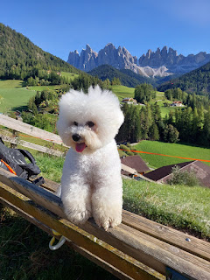

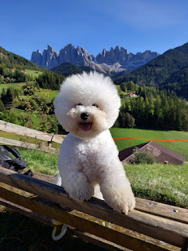

After I took his photo (he's SOOO photogenic), I held my hand out so he could sniff me and know that I'm a nice person. Ever so gently, and ever so slightly, he gave my hand the most polite, tiny, and shortest little lick I've ever received. XOXO

Flowers on our way back to the car . . .

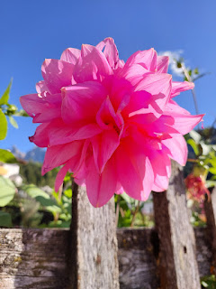

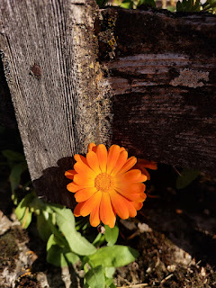

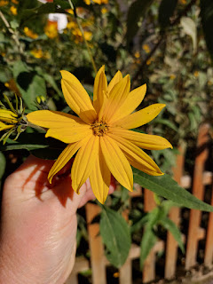

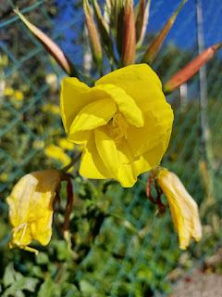

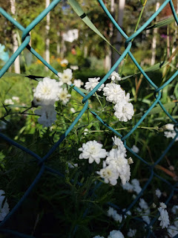

Santa Maddalena has a man-made river that flows right through the center of town. It cascades and flows along in a straight line, with soothing and striking sounds as the water plummets and gushes along.

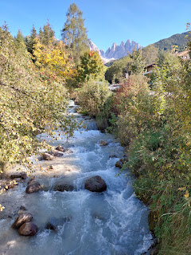

Prepare yourself to see a whole slew of mountainous majesty photos, as seen from the passenger seat of the car between Santa Maddalena and Alleghe, a distance of about 2.5 hours (86 km). Many sections of this road should NOT have been for two-way traffic. It was hair-raising much of the way, and we lost count of how many times we all went into the fetal-position while trying to find a spot to pull over so a car could fit through going the other way. There was even one time where Rich and I could have easily touched the rocky cliff face right outside our window where we squeezed over to let someone pass by. It was maybe 5 inches from my door . . .

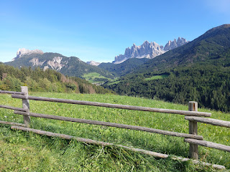

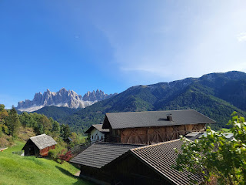

Looking down toward Santa Maddalena below . . . and if you click the photo to enlarge it, you can see the Church that we hiked to earlier.

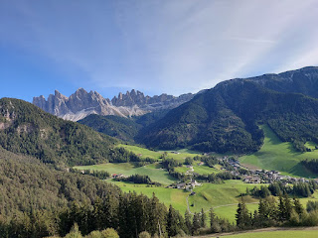

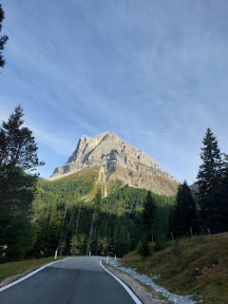

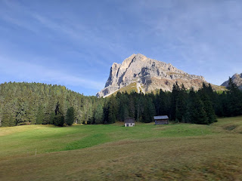

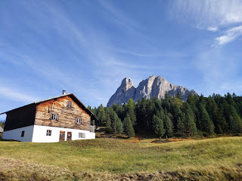

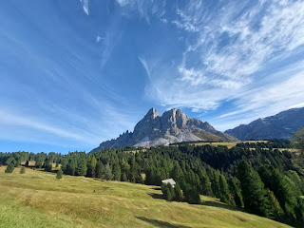

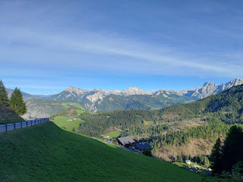

Video while we navigated some "tornantes" (switchback turns): (11 seconds)

https://photos.app.goo.gl/P9iUR1Qcr2WKYgM69

*You might hear Rich say "car" at the end of the video. We were all helping to keep a watch out for oncoming cars while Scott focused on staying on the road and getting through all those sharp turns.

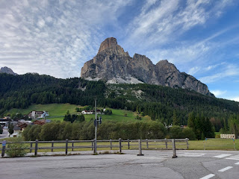

This was a super cute town called Corvara that we passed through. It sits in a very scenic spot among all of the ginormous mountains that it's surrounded by.

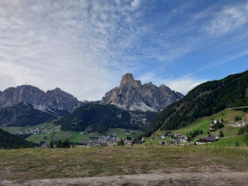

Video going through Corvara: (17 seconds)

https://photos.app.goo.gl/uazP3C3HZvE5pudf6

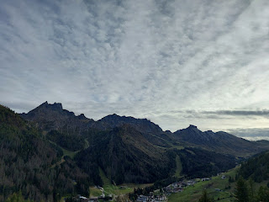

Video showing how high up we truly were: (8 seconds)

https://photos.app.goo.gl/a9jWeMqU7tpHApyK9

Another small town that we passed through: (26 seconds)

https://photos.app.goo.gl/cXBDnheqx5QpAbtN9

Below: (click to enlarge) See if you can find the church that sits high above the valley below. How do the patrons even get up there on Sunday??

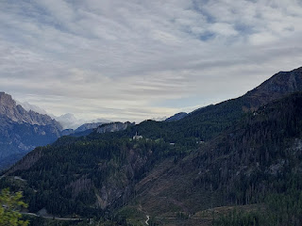

We finally made it into Alleghe, where we could stop for the night. It sits far, far down below the church that I just pointed out. A river flows alongside the road and meanders through Alleghe and on toward Alleghe Lake. Our hotel was right across the street from the river and we could hear it from our upstairs balcony.

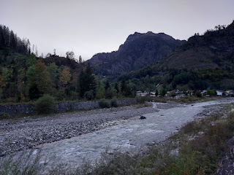

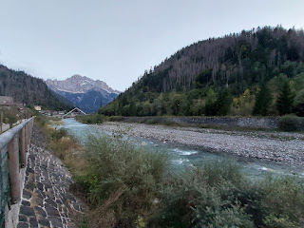

There is a paved walking trail that follows the river, so of course we ventured over to it . . .

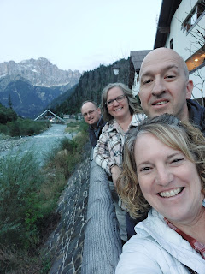

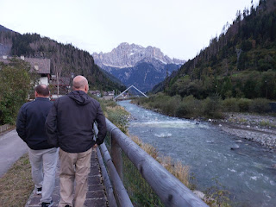

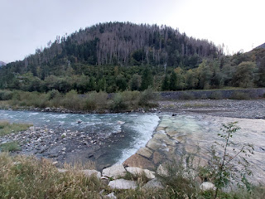

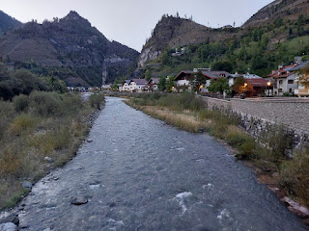

We found a restaurant a little further down the path of the river, which was lucky because with the tiny size of this town, there aren't a lot of options. I ordered the schnitzel, fries, and salad. It was very good!

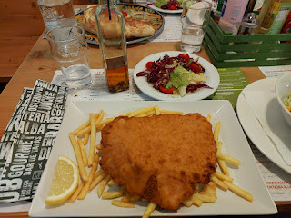

Day Three (of 3):

Cinque Torri Hike, near Cortina d'Ampezzo

After a good night of sleep, and a good breakfast (mine consisted of 2 flapjacks with Nutella, slices of ham and cheese, a boiled egg, and some fruity herbal tea), we were ready to start the day.

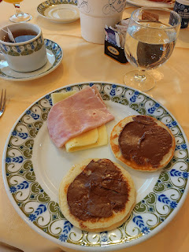

We "enjoyed" several more curvy roads over the mountain passes, to get from Alleghe to Baita Bai de Dones (the location of the chairlift to take us up to our hike). In the photo below, you can just barely make out the craggy jutty-uppy cliff that we would be seeing later.

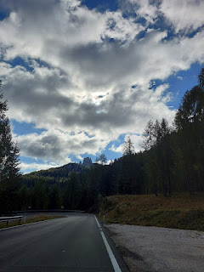

Before I dive into the details of our hike, I would like to give a huge shout-out to our car: "THANK YOU FOR GETTING US UP THE MOUNTAIN SO WE COULD ENJOY THIS SPECTACULAR DAY!!!" I'm so glad we got it fixed a few weeks ago and that everything went smoothly this time.

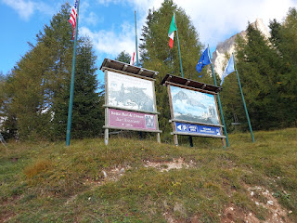

Technically, Baita Bai de Dones is a restaurant. But this is the best address to put into your GPS, and there is a chairlift next to it that will whisk you up the mountain to the actual trailhead for Cinque Torri. (pronounced: cheen-quay torrey)

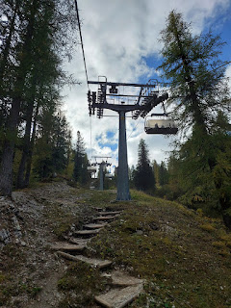

Video as we rode up the chairlift, getting a closer look at the Cinque (5) Torri (Towers): (29 seconds)

https://photos.app.goo.gl/7msBKGxBm8ajcwpdA

Rich, Andrea, Me, and Scottie . . .

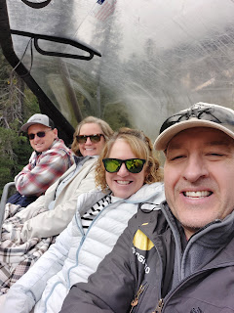

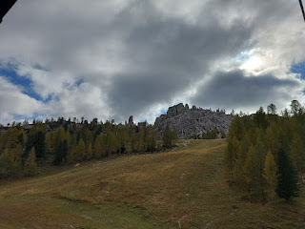

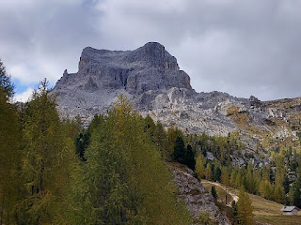

This is the view from the top of the chairlift, where we got dropped off . . .

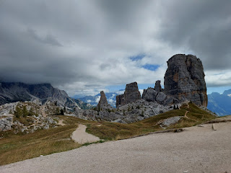

Cinque Torri is a hike that includes epic views for miles and miles, PLUS it's an open-air museum with WWI bunkers, trenches, and artillery, along with plenty of signs that share the history of what happened up here a little over 100 years ago.

The family travel blog that I use the most when I'm doing research is the EarthTrekkers Blog. They are the ones that described this hike and we knew we wanted to try it ourselves.

Here is the link to their blog:

https://www.earthtrekkers.com/best-hikes-in-the-dolomites/

https://www.earthtrekkers.com/cinque-torri-hike-dolomites/

*You are welcome to click on any photo - such as the historical markers (with red) - to read more about WWI in the Italian Alps and what life was like at that time. Or you can skip past all the words and just enjoy the scenic views.

#1: A letter from the mayor, encouraging everyone to remain calm . . .

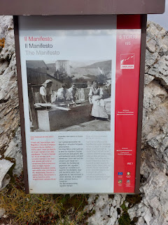

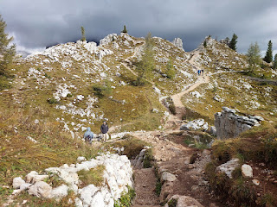

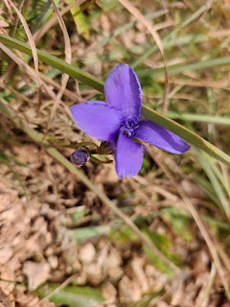

One of several maps placed along the various trails that off-shoot in every direction, so that you can continue to keep your bearings . . .

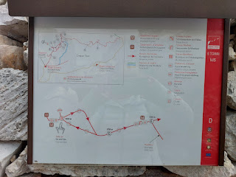

#2: A description of the various military "fronts" (German, Austrian, Russian, Serbian, Italian, etc.)

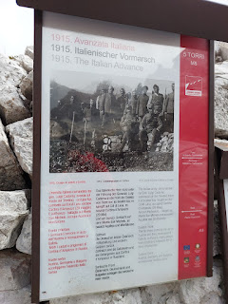

#3: Journal entries describing the war in 1915 . . .

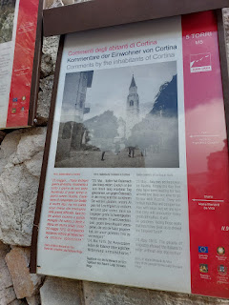

Steep steps descending down to an old bunker . . .

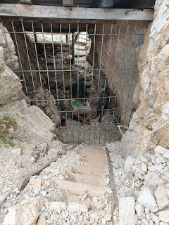

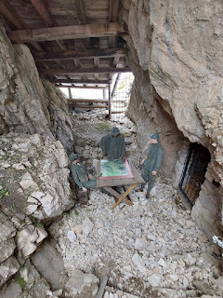

#4: A description of the equipment that was hauled up into these cliffs for the soldiers . . .

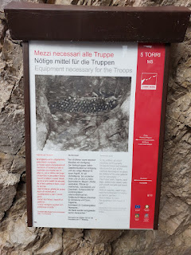

#5: A description of the artillery shelters . . .

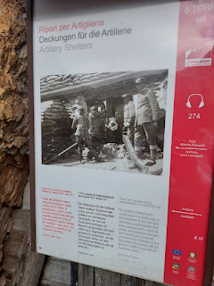

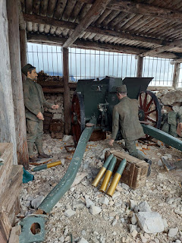

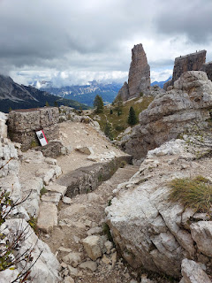

#6: An explanation of the artillery rationing and how each shot needed to be justifiable . . .

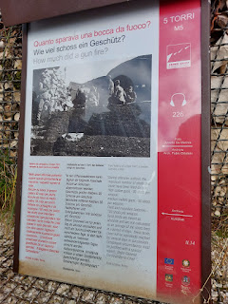

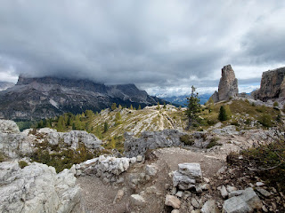

Video of the breathtaking panorama: (14 seconds)

https://photos.app.goo.gl/nznKyEw9tS9Vy2iP6

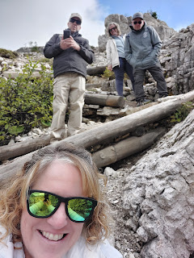

Walking through the trenches was kind of mind-blowing, considering all the action that took place up here 100+ years ago.

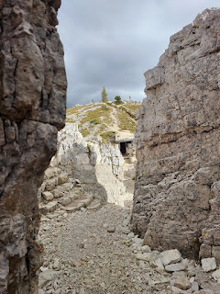

#7: A firsthand account of a medic who experienced the effects of a cannon fire . . .

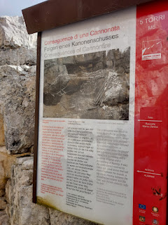

Video as we entered a long trench and bunker: (21 seconds)

https://photos.app.goo.gl/awdwn2StU2RNPRoF9

#8: Issues with using barbed wire and how to stop raids from foreign militia on SKIS . . .

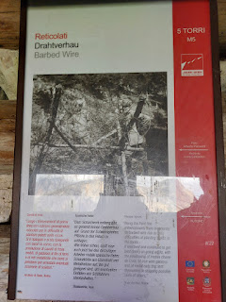

#9: A list of the various batteries, battalions, etc. at Cinque Torri . . .

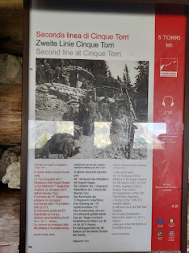

I'm not sure if this was OLD or not, but Andrea pointed out a metal stake in the ground on a section of the trail . . .

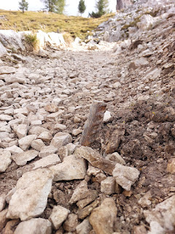

In one of the trenches, Scott set up his drone for some incredible footage. As soon as it's ready, I will share a link to his video in a future blog.

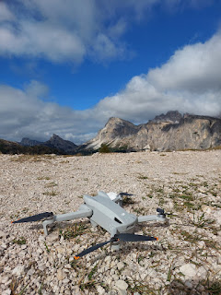

There she goes . . .

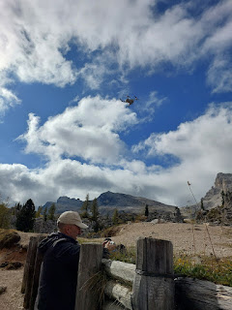

#10: The title says it all: "How many men in the trenches?"

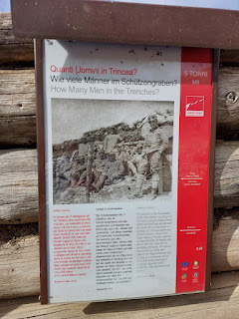

Video of Scott landing the drone on top of the trench embankment wall: (15 seconds)

https://photos.app.goo.gl/PvQsFNmCB5w8XZwx9

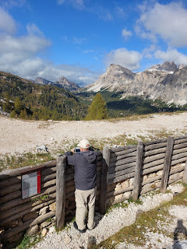

Wow. Just wow.

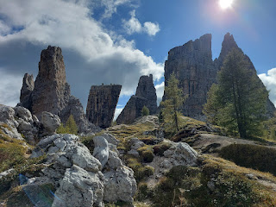

#11: "Life on the front line" - dealing with bugs, lice, wet clothing that wouldn't dry, etc.

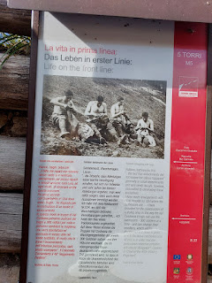

#12: The hustle and bustle as an attack is pending . . .

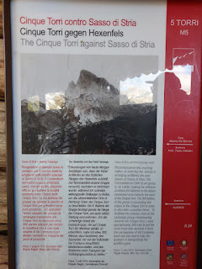

#13: A diary account of a soldier having to run through an "endless whistle of bullets" while under attack . . .

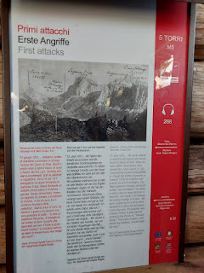

#14: A description of the materials used to form huts and chapels in the trenches . . .

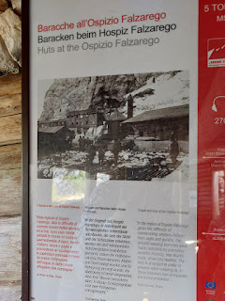

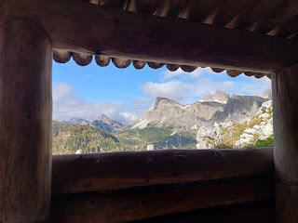

A map we referred to several times - let's just say that it really helps to take a picture on your phone so you can refer back to it again and again . . .

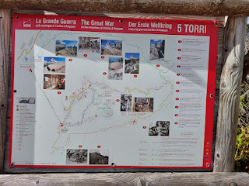

#15: A description of how well the soldiers were being fed . . .

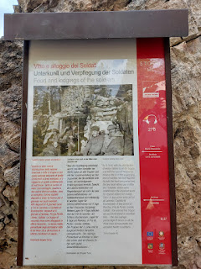

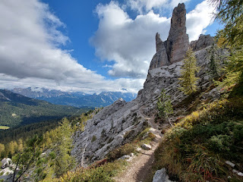

Video as we trudged along the narrow trail (with no railings): (13 seconds)

https://photos.app.goo.gl/92VkqgeYndzveDvv6

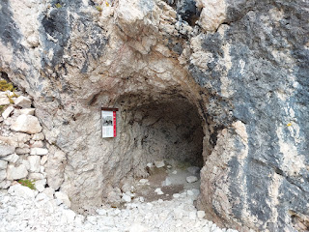

#16: Using what nature gives you as a shelter . . .

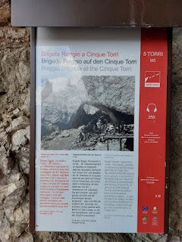

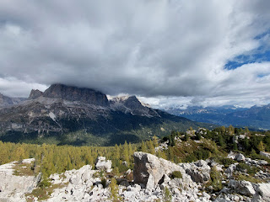

If you look closely at this next photo, you'll see a handful of very brave rock climbers . . .

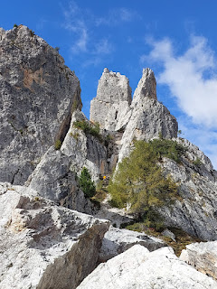

We prefer to "not to" when it comes to climbing 90 degree cliff-faces . . . ha ha

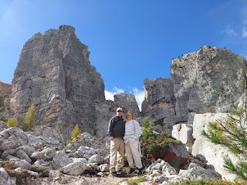

Video of another drone take-off site: (14 seconds)

https://photos.app.goo.gl/kGsCLD6whEGiBAB79

*Note: Even though we were UP THERE already, Scott sent the drone up to its MAXIMUM height of 90 meters, and it still could not get to the top of that giant cliff behind us!! That thing is SO TALL.

#17: A description of the types of artillery that were used up here. How they got Howitzers up here, is a marvel and a mystery . . .

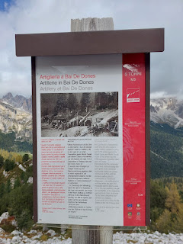

Video of me picking my way down the stone steps on part of the trail: (16 seconds)

https://photos.app.goo.gl/cJozaF5x5KjVC1Rh7

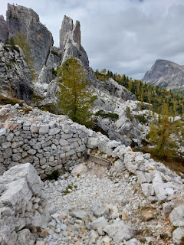

Rich, Scott, and Andrea discussing something important . . .

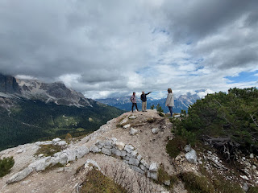

Scott and me . . .

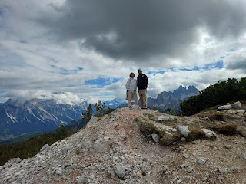

A rifugio is a mountain hut for hikers and skiers: for a hot meal, for shelter, and to rest. Rifugio could essentially be translated as "refuge". We made it to Rifugio Cinque Torri, excited to have a bathroom break and maybe a snack. But it was CLOSED. How disappointing . . . Someone had set out several mattresses to air out in the sun, though.

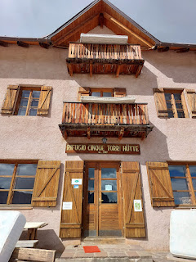

So, onward we went. We circled around the tallest "Torri" (on the left in the photo below), to make our way back to the chairlift.

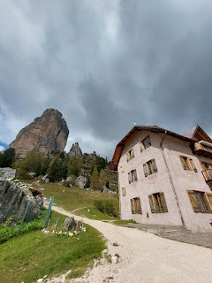

Scott kept saying how much he wanted to TOUCH the rock wall, mumbling something like, "if there was only a way to get up there . . ."

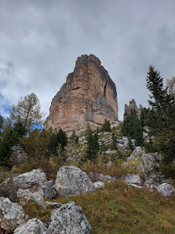

We would have to be quick, though, because there was a storm a-brewing and we did NOT want to be caught in that.

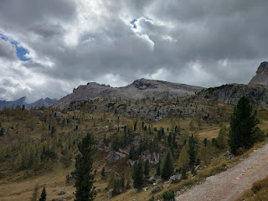

After much begging and pleading, I said okay to blazing our own trail up the mountainside so my best friend could touch the rock wall. I wish you could have seen the joy on his face when I agreed to do this. I was the slowest one in the group, on account of my childhood asthma, but everyone voted to make me the leader of our expedition so we could go at my pace. I had already used my inhaler, and I'm sure it did help somewhat, but when you're up at this kind of altitude, it's a whole other level to be able to breathe properly.

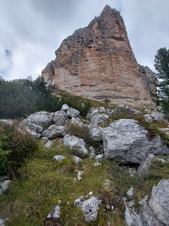

I picked my way over rocks and bushes, asking for input from time to time from Scott who was right behind me. When you're "in the trenches" of bushwhacking, it helps to get perspective from someone else who is a little further back in order to choose the next directional push.

About 90% of the way up, I had to pause to catch my breath for a bit, so Scott clambored up ahead of me, eager and excited to go touch that rock wall . . .

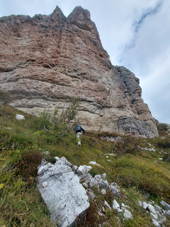

And he did it!! He was like a little kid in a candy store. Or a little boy splashing in the mud. It made me so happy to see him so happy.

Video of him touching that giant rock wall and the sheer height of where we were: (20 seconds)

https://photos.app.goo.gl/cwxw2DjqNKUgviB88

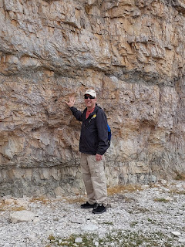

Meanwhile, he was the best coach and friend and support for me as I slowly made it all the way up there, as well. He kept saying things like, "I'm so proud of you, honey!" and "I love you SO MUCH!!" and "You're doing awesome, hon." and "You make me SO happy!" and "You're a beast! Look at you - you're doing it!"

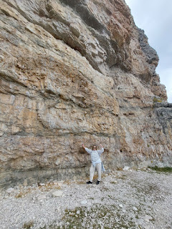

I was pretty proud of myself, too. We CAN do hard things in this life. We really can.

One more lap with the drone . . .

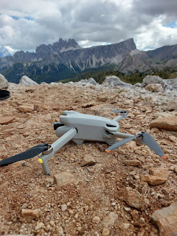

While we sat on the rocks, resting, we found a super old tin can amongst the rocks. I wondered just how old it really is . . . could it have been a part of the rations belonging to those brave soldiers 100+ years ago?

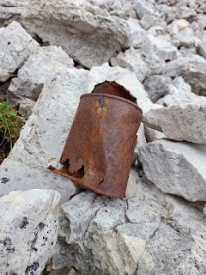

The views from the Cinque Torri trail will never get old . . .

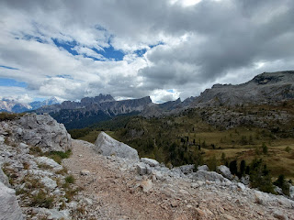

Behind me on the final stretch of the trail: Scott, Andrea, and Rich . . . The hills are alive . . .

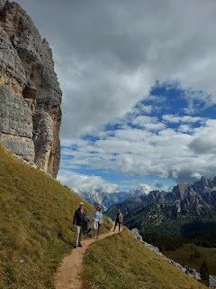

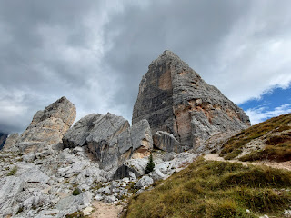

Rich had a theme throughout their 8 days with us: Take photos of him with his disc golf disc in various scenarios. Yes, I know, "disc golf disc" is repetitive, but I don't know how else to define it, ha ha. Anyway, he had a lot of fun staging a "putt" from the top of a castle, over a lake, in a Basilica, and yes, on Cinque Torri. He packed it around everywhere in his cinch-sack, always ready for a great photo opportunity.

In this case, however, he wanted to actually "drive" his disc across a section of the trail toward a sign post as his "basket" (or target).

Watch how well he did here: (11 seconds)

https://photos.app.goo.gl/w8hgHJ9rvFCnySiF8

Below: he is about to throw the second "approach" shot, from where it landed on the first drive. His target is the sign up above him on the left.

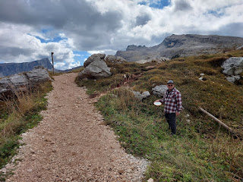

His final "putt" shot actually ticked the sign post, so he made his target basket in just 3 shots!! Wowzers.

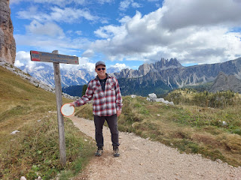

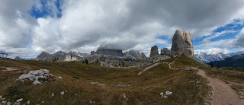

I bet they'll use this picture on their upcoming Christmas cards . . . XOXO

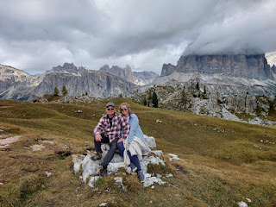

Next to the chairlift is a restaurant and resting spot, with a variety of foods, drinks, and lots of alcohol. Andrea and I ordered an Italian hot chocolate, which they serve up with a spoon because it's so thick. Yummm...

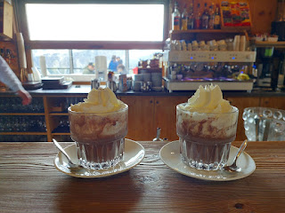

And the vegetable soup was absolutely 100% the best I've ever had!! And I don't think it had to do with the fact that I was hungry and had just finished a lengthy hike. It was truly spectacular. A flavorful broth with lots of chopped carrots, celery, zucchini, herbs, onions, and a sparse amount of little potato bits. My mouth would like some more of that soup, now that I'm thinking about it . . .

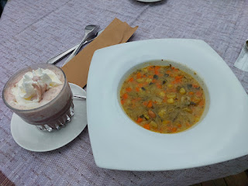

Andrea and me - celebrating our victorious hike, our tasty food, and 28 years of friendship . . .

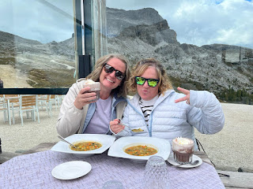

Behind us, through the plexi-glass, is a trail that leads up to another refugio hut. It didn't look that hard, and I wouldn't mind trying it again someday. :)

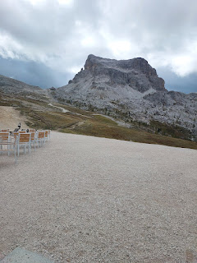

The restaurant and top of the chairlift sit at 2255 meters. That's equal to 7398 feet in elevation. Nice.

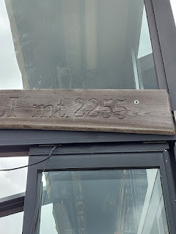

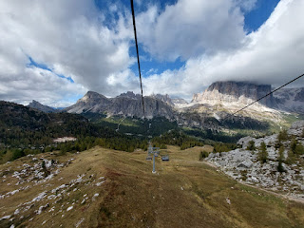

Alas, all good things must come to an end. It was time to descend back down to the parking lot below and begin the long drive home to Vicenza. In all, we spent about 4 hours on the Cinque Torri Trail. On the EarthTrekkers blog, they suggest that you'll spend about 1 hour on this hike. But we did a lot more exploring, I think, plus we needed time to fly the drone 3 separate times. Plus we added on the extra leg over to the Refugio - the one that ended up being closed. So all of these things added additional time to our day.

Video as we rode the lift down: (5 seconds)

https://photos.app.goo.gl/YiDuwfFLibkamdHJ9

*You'll hear Andrea and Rich on a video call with their kids back in the U.S. Andrea is afraid of heights, so she was not very enamored with the chairlift, bless her heart. She's also fallen off one before - not from a substantial height, but still, it messes with your mind when you're already deathly afraid of what might happen.

So you'll hear her saying in the video clip something like, "I haven't fallen off yet . . ."

We were very proud of her and how she worked through her fears to accomplish something magnificent. What an amazing day, on an amazing mountain, with some amazing people to share it all with.

